**JS: Weather app using API integration in Flutter**

**Nama: Muhammad Taufiq Abdus Salam(22)**

**Kelas: SIB 3D**

**Tugas Cuaca**

**Hasil RUN:**

**Jakarta: Batu:**

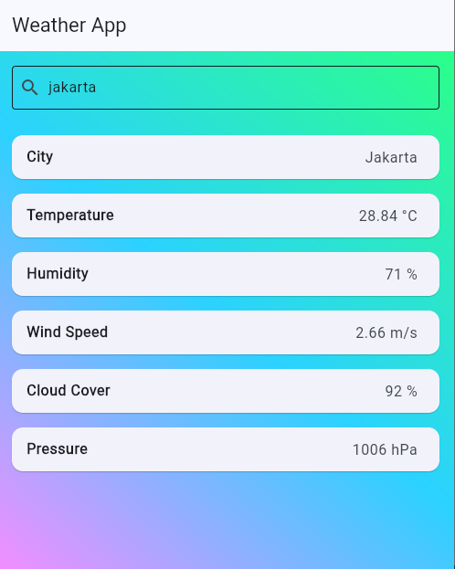 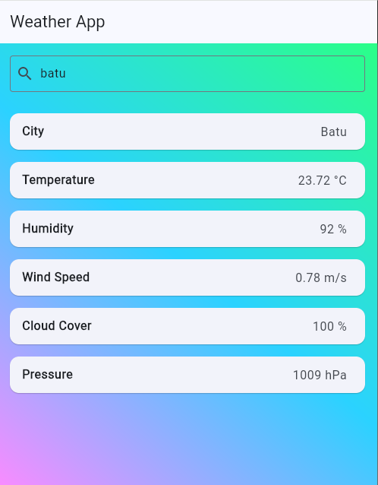

**GitHub:**

[**https://github.com/MuhammadTaufiqAbdusSalam/Pem-Mobile/tree/main/Pertemuan%2012**](https://github.com/MuhammadTaufiqAbdusSalam/Pem-Mobile/tree/main/Pertemuan%2012)

**Malang: Mojokerto:**

